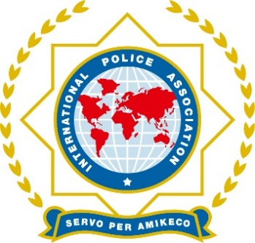**INTERNATIONAL POLICE ASSOCIATION**

**CYPRUS SECTION**

**LEMESOS - CYPRUS**

**Tel. 357-25 819 598**

**Fax. 357-25 819 599**

**E-mail** [**ipa.cyprus@cytanet.com.cy**](mailto:ipa.cyprus@cytanet.com.cy)

**www.ipa-cyprus.com.cy**

25 July, 2025

**42nd National Congress of IPA Cyprus Section**

**13-16 November 2025**

**Paphos**

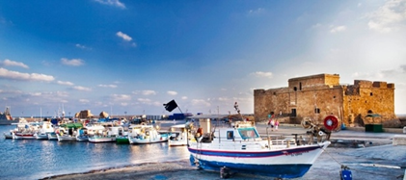

**To:** All IPA members

Dear IPA Friends,

It is with an honor to announce you the launch of the 42nd National Congress of the IPA Cyprus Section, which will take place from 13th to 16th November 2025 in the beautiful coastal city of Paphos, in Cyprus.

All the participants and the guests will be accommodated at the Aliathon Resort, in Paphos, where the congress will be held as well.

For the IPA Members who are interested in participating to the 42nd National Congress, please find below all the necessary details.

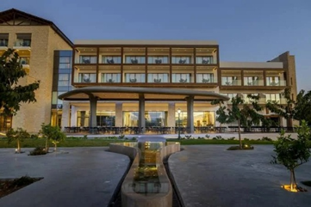

**Cost**:

* €340 per person in a shared double room,
* €460 for a single room,
* €310 for a triple per person

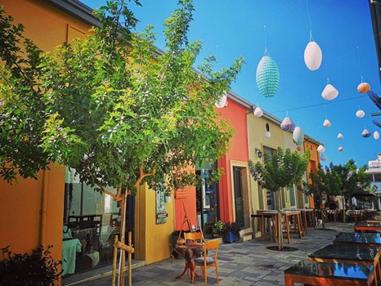This fee includes 3 nights of accommodation, all meals, transportation, excursions, and the Gala Dinner.

Payment can be at to our Bank Ac:

Hellenic Bank

DIET.SYN.AST.TM.KYP.(I.P.A.-CYPRUS)

IBAN: CY77 0050 0281 0002 8101 G464 9907

BIC: HEBACY2N.

All participants must complete and return the **attached Registration Form no later than 30th September 2025**, by email to: [**ipa.cyprus@cytanet.com.cy**](mailto:ipa.cyprus@cytanet.com.cy)

For any further information, please contact the Secretary General,  
**Mr. Kikis Perikleous**  
📞 Tel: +357 99 624006

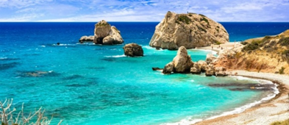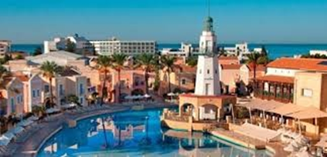

Until then, we send you our warmest wishes and look forward to welcoming you to Cyprus!

**Yours in Friendship,**

D. Demetriou K. Perikleous

President IPA Secretary General

Cyprus Section Cyprus Section