

IPA Section Montenegro is organizing socializing in Kolašin, Montenegro, in the north of Montenegro, from June 16 to 19, 2024, with the aim of developing friendship and international cooperation among IPA members, promoting ecology and healthy lifestyles.

Participants will visit two national parks and the canyon of the Tara River. Rafting and ATV rides are organized.

**Schedule**

**June 16**

Arrival of guests

Dinner at the hotel and free time

**June 17**

Departure for rafting on Tara, the big bridge on Tara and lunch

18.00 Return to the hotel - free time - dinner at the hotel

**June 18**

09.00 Departure to Durmitor National Park (tour of the Black Lake and ATV ride)

14.00 Lunch

15.00 Tour of Biograd Lake in Biogradska Gora National Park

17.00 Return to the hotel, free time, dinner at the hotel

21.00 Dance evening and presentation of gifts

**June 19**

The breakfast

Departure of guests

**Accommodation at Hotel Bjanka in Kolašin**

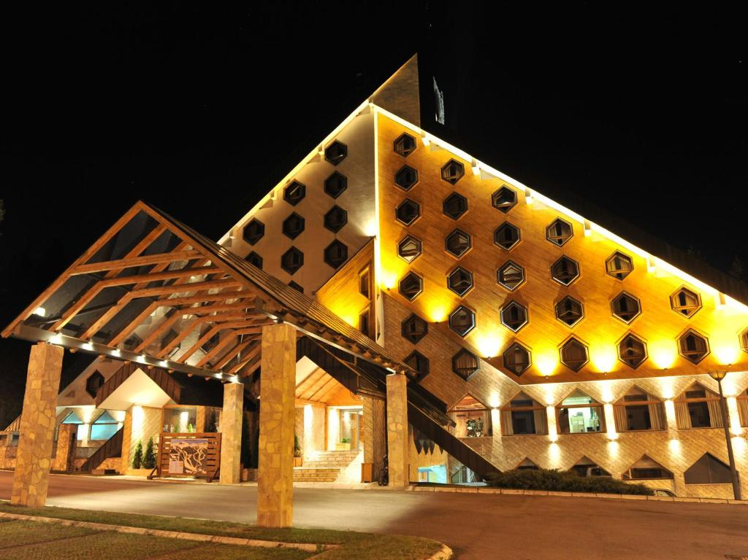 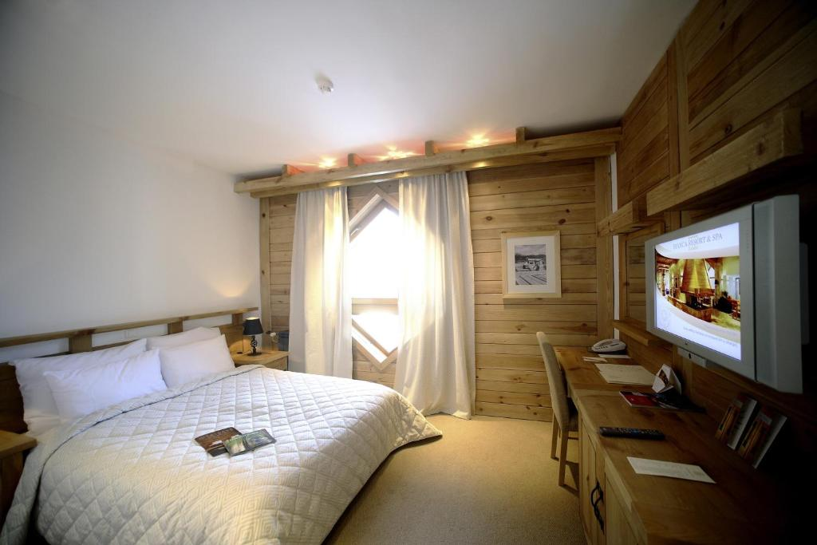

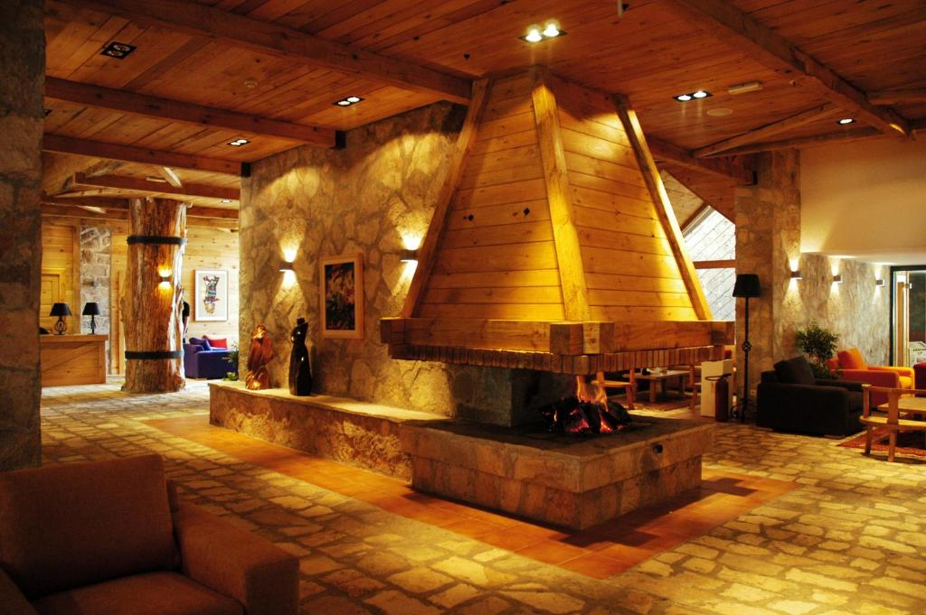 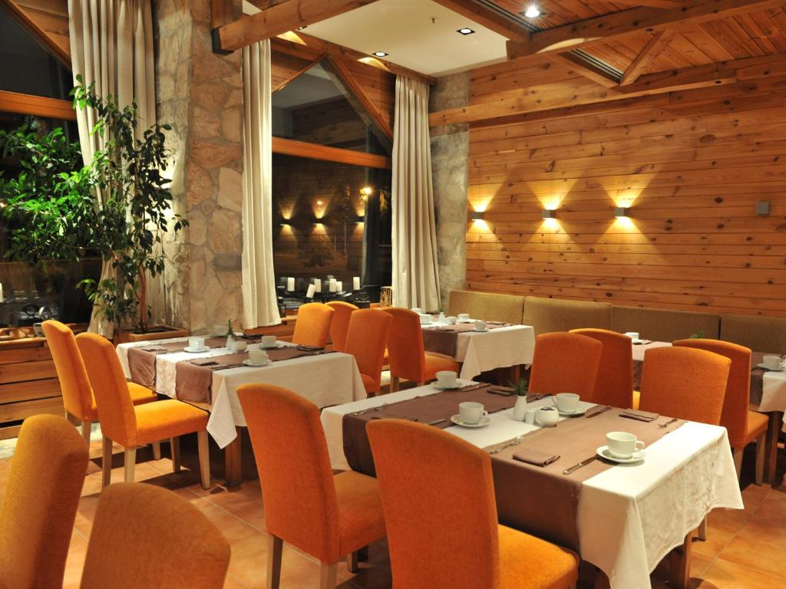

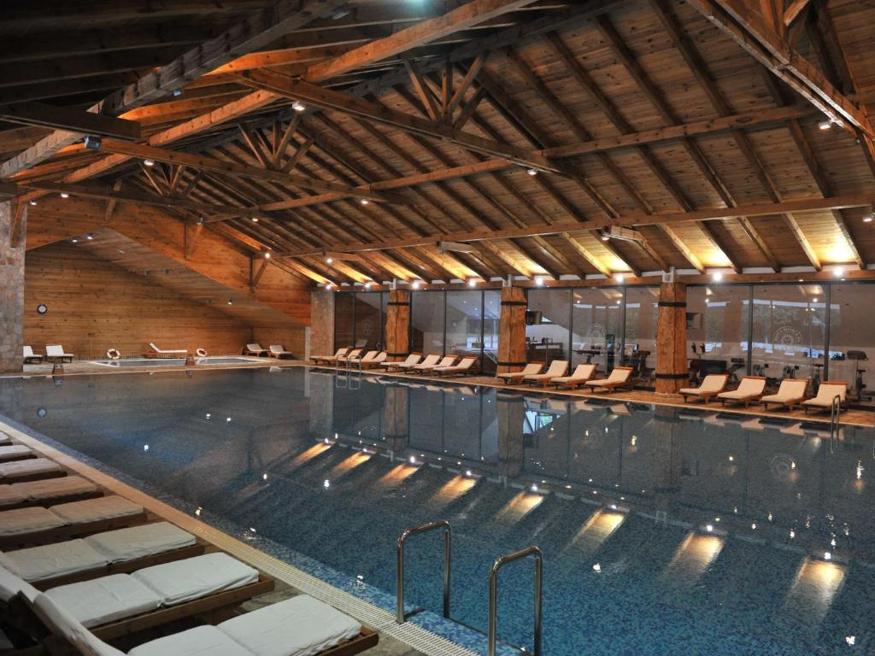 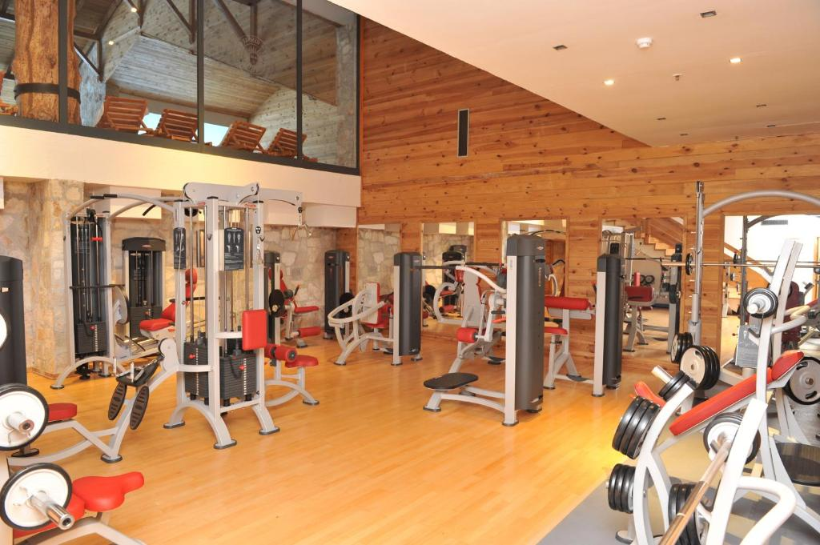

**Durmitor** is a mountain and a national park in Montenegro. The highest peak is Bobotov kuk, 2,523 m high. The beauty of Durmitor is given special charm by 18 glacial lakes, called mountain eyes, at heights above 1500 m. The largest and most attractive is **Black Lake**. Vast forest areas contribute to the magnificence of the landscape. Durmitor National Park is part of the World Cultural and Natural Heritage.

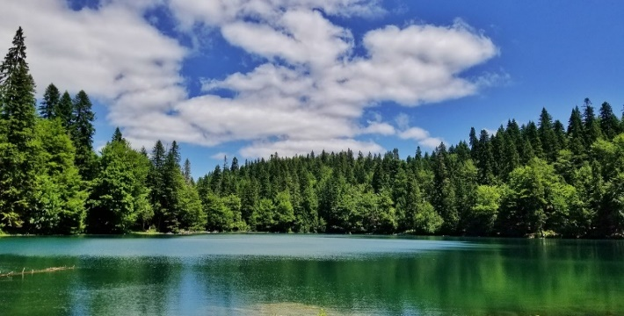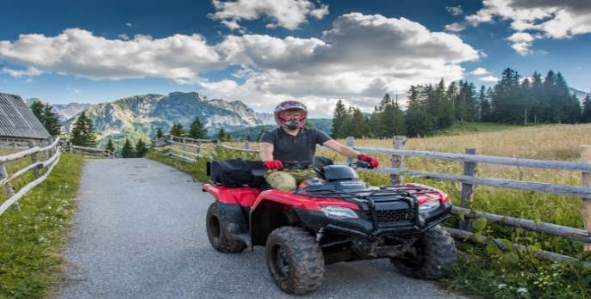

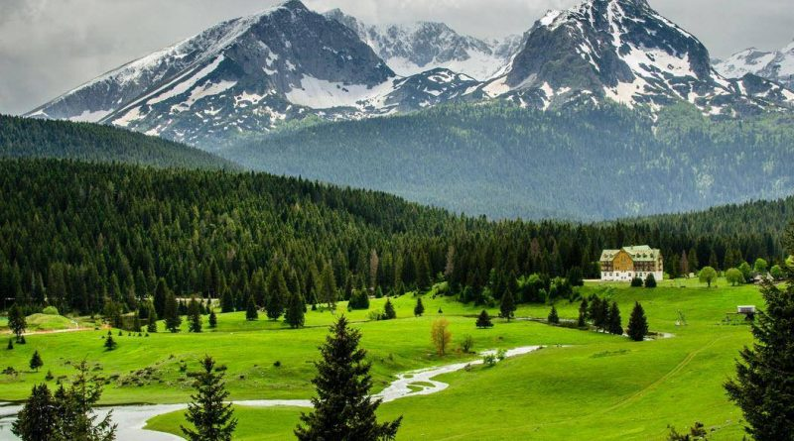 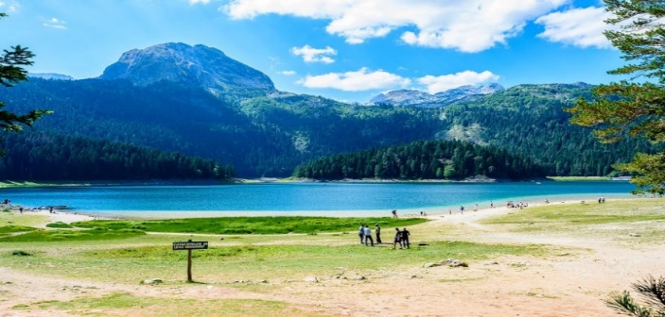

**Tara**, an impressive river, has one of the most beautiful canyons in the world, up to 1,3000 m deep, which makes it the deepest canyon in Europe and the second in the world, after the Grand Canyon of the Colorado River in the USA. The **Great Bridge on Tara**, one of the 20 most beautiful in the world as chosen by the "Bright side" portal, and the British "Times" ranked it among the 10 attractions that should be visited. Tara and its canyon valley have been included in the world ecological biosphere reserves by the UNESCO program.

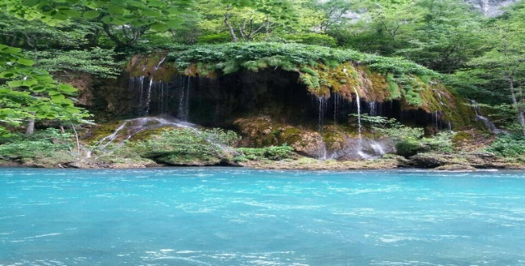 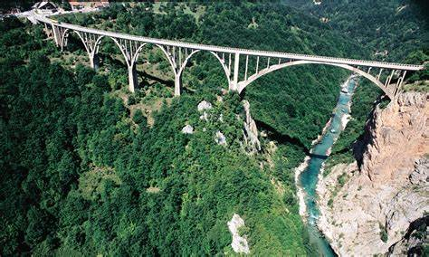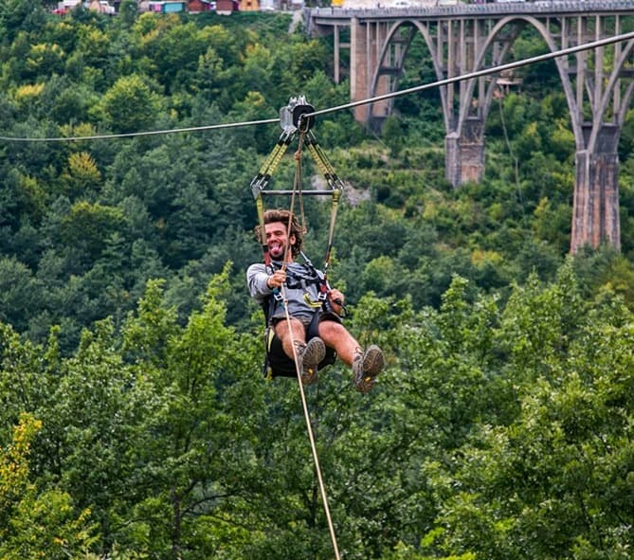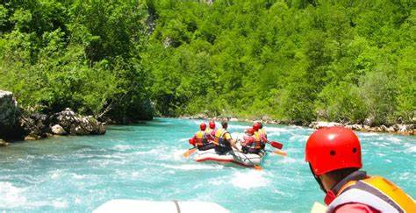

**Biogradska gora**, one of the last three rainforests in Europe, is a specially protected place in Montenegro. This untouched corner of the beauty and splendor of nature, in its ancient forests, also hides a real gem - **Lake Biograd**, which is located in the central part of the Biogradska Gora National Park. Mount **Bjelasica** is one of the most beautiful mountains in Montenegro, where the largest Montenegrin ski center is located. The highest peak of Bjelasica is Crna Glava, 2,139 meters high.

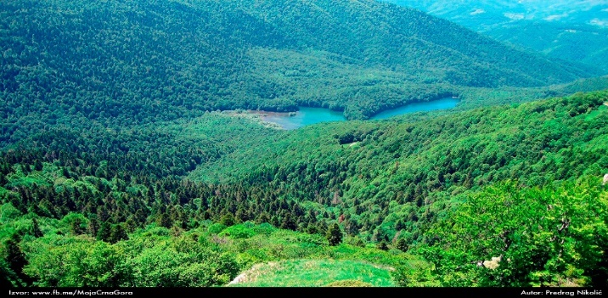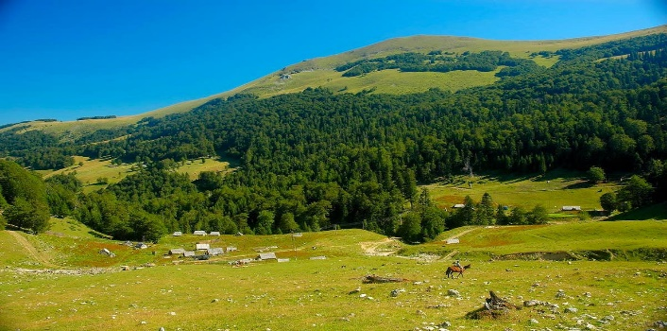

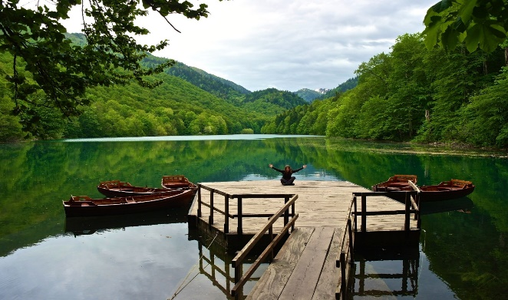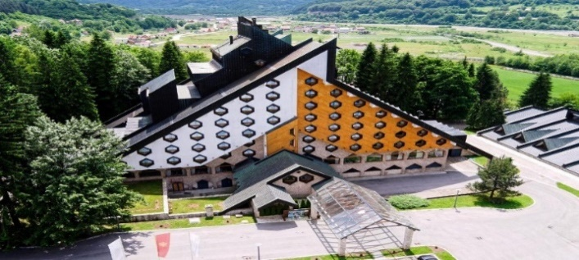

**Montenegrin gastronomic offer**

 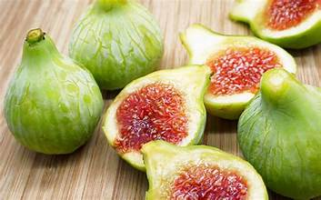

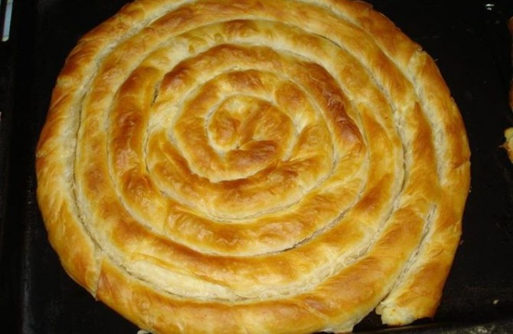 

**Price per person:**

Double room **360e**

Twin room **385e**

Single room **435e**

**The price includes:**

- 3 half-boards at the Bianka Hotel in Kolašin, with use of the swimming pool and SPA center,

- stay tax and hotel insurance,

- 2 lunches during the trip,

- festive evening,

- transfer on the route Podgorica Airport-Kolašin-Podgorica Airport,

- transportation to national parks for two days,

- entrance to national parks for two days,

- rafting on the river Tara,

- ATV driving.

**Applications by the end of May 2024** at ljiljanab73@yahoo.com and payment of the total amount to the account of the Montenegro Section (payment instructions are attached). Bank costs of money transfer are paid by the participant (OUR option).

For additional information, you can contact ljiljanab73@yahoo.com