INVITATION TO THE X INTERNATIONAL IPA MEETINGS SARAJEVO 2024

Dear IPA Friends,

We are honored to invite you to participate in the traditional X INTERNATIONAL IPA MEETINGS "SARAJEVO 2024," which will be held in Sarajevo from August 15-18, 2024.

For this occasion, we have arranged accommodation for you at Hotel BM International.

The registration fee for the program from August 15-18, 2024 (Thursday – Sunday) is EUR 140.00.

The registration fee for the program from August 16-18, 2024 (Friday – Sunday) is EUR 80.00.

Registration fees should be paid in person upon arrival or to the IPA R.K. Sarajevo account Addiko Bank Trg Solidarnosti 12, Sarajevo 71000 SWIFT:HSSBBA22 BA393060002722616728

All participants are requested to make hotel reservations by the latest August 1, 2024, via email or phone at: sarajevoipa@gmail.com or phone numbers: Muamer Klino +38762915555 and Damir Zgodic +38761894027

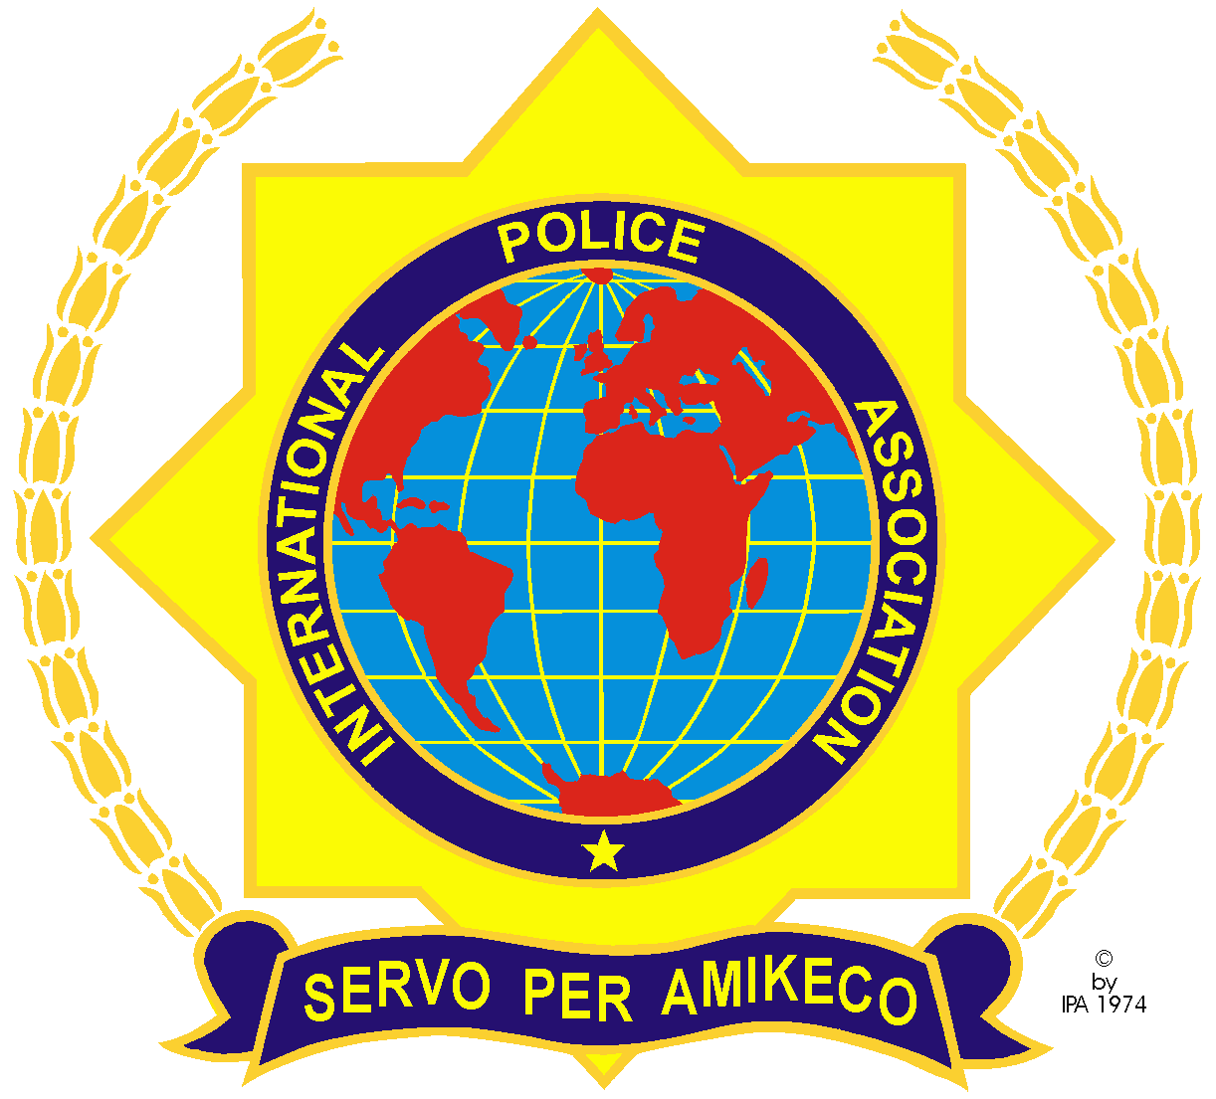

PROGRAM X INTERNATIONAL IPA MEETINGS SARAJEVO 2024

THURSDAY, August 15, 2024
- 18:00 to 20:00, guest reception in front of Hotel BM International

FRIDAY, August 16, 2024
- ALL INCLUSIVE Rafting on the Neretva River, departure from the hotel at 07:00, return by 18:00.
- 19:00, dinner.
- 20:00, tour of the historical core of Sarajevo, free time activities.

SATURDAY, August 17, 2024
- 07:00, breakfast.
- 08:00, departure to the competition sites.
- 18:00, return to the hotel.
- 20:00, gala dinner, award ceremony, with full evening program including food and drink.

SUNDAY, August 20, 2024
- From 09:00 to 11:00, guest departure in front of Hotel BM International

NOTE: The program may change depending on weather conditions.

PROGRAM X INTERNATIONAL IPA MEETINGS SARAJEVO 2024 BY SPORTS

- Mini Football 4+1
- Basketball 3x3 (Men/Women)
- Table Tennis (Men/Women)
- Precision Shooting (Men/Women) PISTOL 25m (first prize a pistol, along with other valuable prizes).
- Athletics 5000 meters (Men/Women)
- Open Type Billiards
- Darts (Men/Women)
- Boxing (M)

NOTE: Only IPA members may participate in the competitions, valuable prizes along with trophies are provided for all sports.

With the hope that you will support the above project, and warm regards with the motto "servo per amikeco," which translates to "let's socialize and respect each other."

Warm regards.
Sekretar
Damir Zgodic

