30th NATIONAL IPA CONGRESS OF THE SLOVAK SECTION
BRATISLAVA 06. – 09. JUNE 2024

PROGRAMME

THURSDAY  06.06.2024 | -  14:00hrs  20:30hrs | Arrival of foreign delegations. Transfer from the airports Bratislava or Wien to the SAFFRON HOTEL in Bratislava  Welcome Drink and dinner at the Hotel
FRIDAY  07.06.2024 | 07:00-09:00hrs  09:30hrs  19:00hrs | Breakfast  Departure for the excursion  Lunch in a traditional restaurant  Dinner combined with wine tasting, near Bratislava  Return to the Hotel – Free Time
SATURDAY  08.06.2024 | 07:00-08:15hrs  08:30hrs  09:00hrs  10:00hrs  10:15hrs  13:30hrs  19:30hrs | 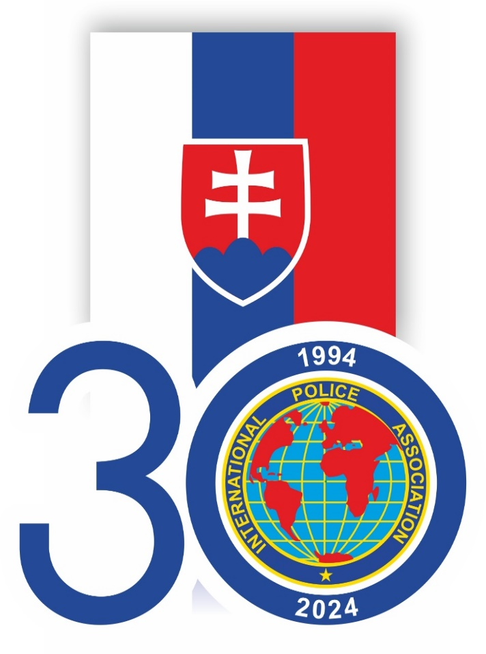  Breakfast  Leaving for the National Congress  NC in the Police Academy Opening Ceremony  Official Photo  Departure of the guests for an excursion in the area  Lunch at the Police Academy with the members of the Slovak National Board  Afternoon – Free Time  Gala Dinner – Gifts Exchange
SUNDAY  09.06.2024 | - | Breakfast/Departure of the Delegations  Note: For the Foreign Delegations there will be transport arranged to the airports Bratislava or Wien

