To the President of IPA Section Slovenia January 2024

Dear friend,

30th National IPA Congress of the Slovak Section
Bratislava 06. – 09. june 2024
30 years IPA Slovak Celebrations

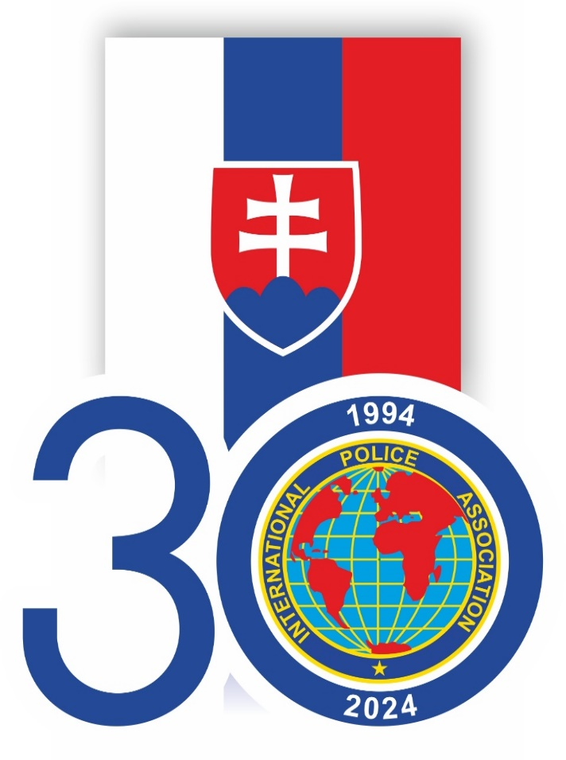
The 30th National IPA Congress of the Slovak Section will be hosted by the Slovak section of IPA between 06. – 09. June 2024 in the capital of the Slovak Republic in a beautiful city on the river Danube – Bratislava. Simultaneously, the Slovak Section will celebrate its 30th anniversary.

Your National Section is invited to participate with two members.

The Slovak Section will cover the, transportation, excursions’ costs, gifts and meals including Gala dinner, for the two delegates from your Section for the period between the 06 – 09 June 2024 in a double room in the Hotel Saffron Bratislava.

For the other IPA members of your section who want to participate, the costs have not yet been determined exactly.

If you are interested, please contact us in the way indicated below, during the month of February, when we will give you the exact prices and the method of payment. If Saffron Hotel is overbooked, reservations will be made at a hotel of the same category next to the main hotel. The price includes accommodation for 3 nights - food, transport, excursions and a gala dinner.

Please find the programme attached.

Both invited guests and visitors will have to complete the attached Registration Form and return it to us by 15th of March, 2024 the latest (email: ipa.sectionslovakia@gmail.com). For further information, you may contact the President Ján Ignaták, Tel. +421 – 905 26 38 44 or janignatak2@gmail.com.

We wish you all the best and we are looking forward to seeing you in the Slovak Republic for our National Congress and the celebration of our 30th anniversary.

Yours in Friendship,

Ján Ignaták
President IPA
Slovak Section

